Order Of Service

Singing: Psalm 85—CW page 97

Reading: Psalm 138

Opening Hymn: CW 492

Reading: James 5:7-19

Request Hymn: CW Supplement 752

Reading: Luke 20:19-26

Sermon Hymn: CW 440

Sermon Text: Song Of Solomon 2:3b

Under His Shadow

Prayer

The Apostles’ Creed, TLH page 12

Holy Communion

The Lord's Prayer

The Blessing

Closing Hymn: CW 327

* * * * * * * * * * *

Bible Study: Lambs: Luke 21:1-4; Giving To God
Sheep: Proverbs 6:6-11; Your Choice
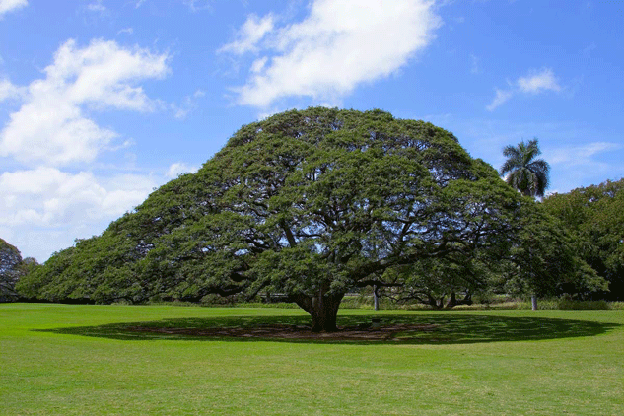

Under His Shadow

Water
Of
Life

8 November 2015

W A T E R O F L I F E

Independent Christian Church—Conservative Lutheran Doctrine

Worship Service: 9:30 a.m. Bible Study: 10:45 a.m.

Larry Cooper, Pastor E-Mail address:
111 N. Ridge Road lcooper@wateroflife.cc
Coon Valley, WI 54623 Web Site:
Phone: (608) 452-2105 www.wateroflife.cc

* * * * * * * * * * * * * * * * * * * * * * * * * * *

Sermon Text: Song Of Solomon 2:3b

Under His Shadow

* * * * * * * * * * * * * * * * * * * * * * * * * * *

3b: I sat down under his shadow with great delight, and his fruit was sweet to my taste.

In Psalm 1 the Bride of Christ is cautioned not to sit in the seat of the scornful. “Blessed is the man that walketh not in the counsel of the ungodly, nor standeth in the way of sinners, nor sitteth in the seat of the scornful.” Those who fail to take this warning to heart are “like the chaff which the wind driveth away.” And they meet with a bitter end. “The way of the ungodly shall perish.”

There is a place, however, where the Bride of Christ can sit down to rest. That place is in the shade of The Apple Tree—which is Jesus Christ. Drawn by the Holy Spirit, she does that. And the results are pleasantly amazing. Let her tell it—“As The Apple Tree among the trees of the wood, so is my beloved among the sons. I sat down under his shadow with great delight, and his fruit was sweet to my taste.”

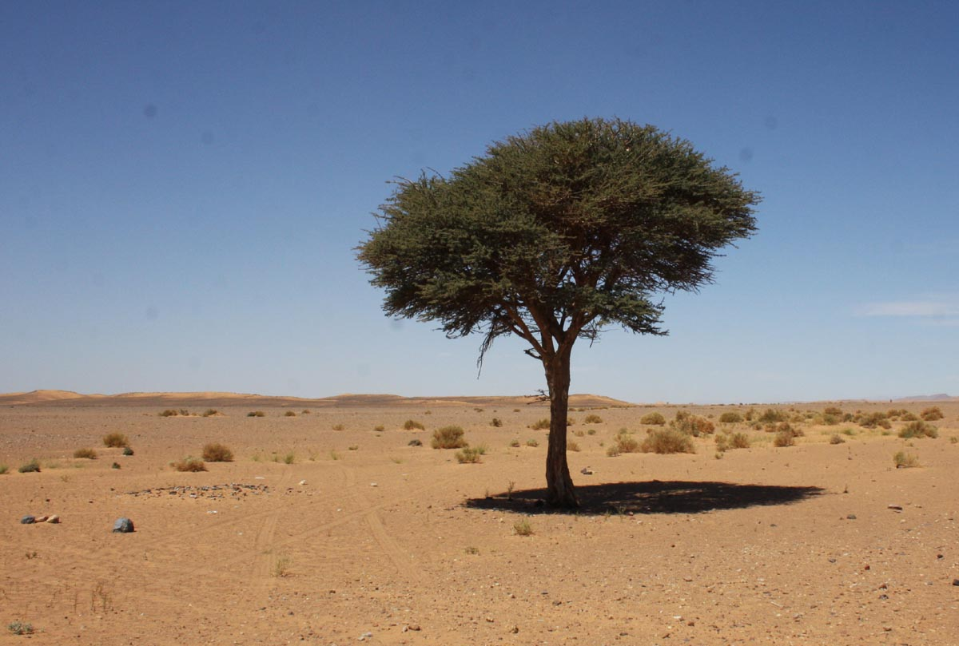

So as we wander “through that great and terrible wilderness, wherein were fiery serpents, and scorpions, and drought, where there was no water,” we have one place of shelter and rest from the hot, blazing sun. But only one! And that place is under The Apple Tree.

The end result is blessed beyond human words. We’ll let the Holy Spirit tell it: “And he shall be like a tree planted by the rivers of water, that bringeth forth his fruit in his season; his leaf also shall not wither; and whatsoever he doeth shall prosper.” Psalm 1:3.

Blessedly we take on the character of the very tree we sat down under for rest and safety. We shall “be like him; for we shall see him as he is.” I John 3:2b.

